Name:_________________________Per.________

Teen files: Surviving High School
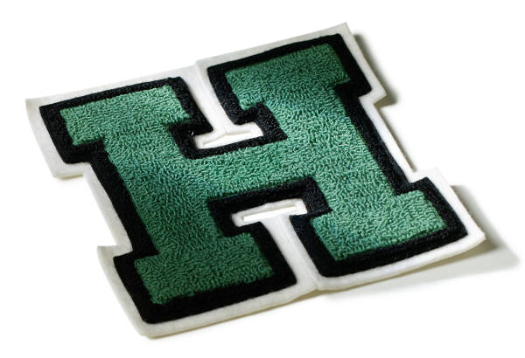
Key Points: Host Leeza Gibbon Addresses
- ________% of teenage girls report being unhappy with their bodies.
- This year one _________________teens will die from anorexia nervosa.
- One in ________ adolescents suffers from depression.
- Every ________, a person under the age of 24 attempts suicide.
- An estimated ________% of teens have been bullied or harassed by their classmates.

- List the different groups/cliques given by the students in the movies.

- Why do you think groups/cliques exist?

- How did Mike & Erica feel being the (outcast) new student? (explain)

- What did it take for the teens to be successful during the challenges they did at the retreat? (rope, rock, stereotyping, drawings, etc.)

- What are 3 side effects of steroid use the former NFL football player Keena Turner explained?

- What are some characteristics of eating disorders that the former model Magali Amadei and the patient Amanda Wood both experienced?

- What are some things photographers do to enhance photographs of models?

- How does that make you feel knowing that photographers are able to do this false advertising scheme?

- What are some warning signs of suicide that Debbie and Roseanne share with the teens?

- What did the students do to challenge their school when they returned?

- What message did they send back to the students at Yuba City High?

- What does this movie have to do with surviving high school?

- What are things you can do to prevent bullying, stereotypes, and harassment from happening at your school?

19) Assuming everyone has been picked on or bullied, how has this movie changed your perspective? (explain)

20) How can other teens benefit from watching this movie?

